Lab 1: Team Collaboration – Missing Changes

Scenario:

You and your teammate are working on the same project. Your teammate pushed an

update to the README.md file directly to GitHub. You already made local changes to the

same file but haven’t committed yet.

Tasks:

1. Clone the repository from GitHub.  
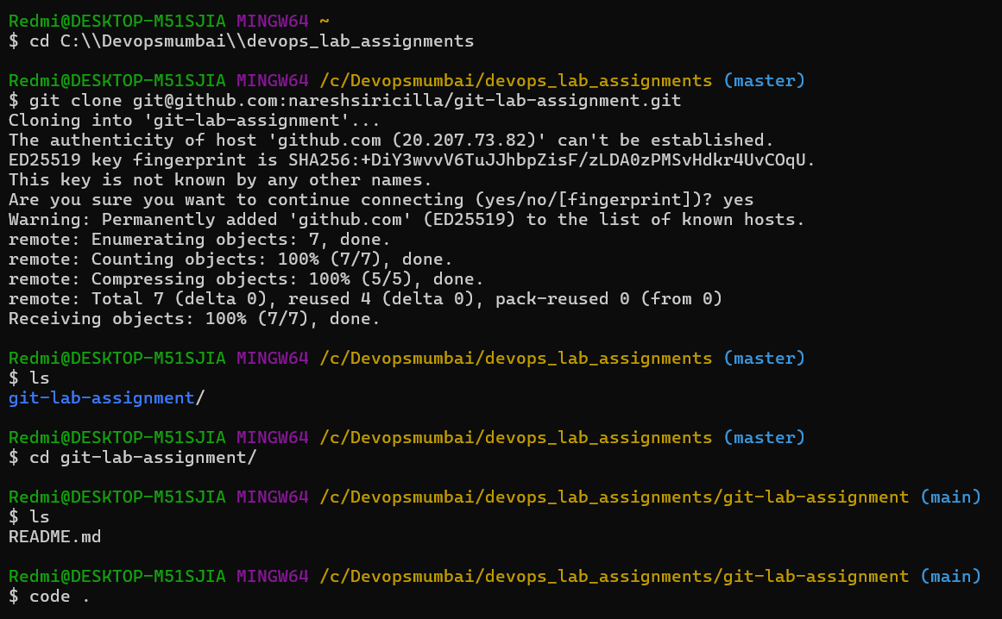

2. Edit the README.md locally (don’t commit yet).  
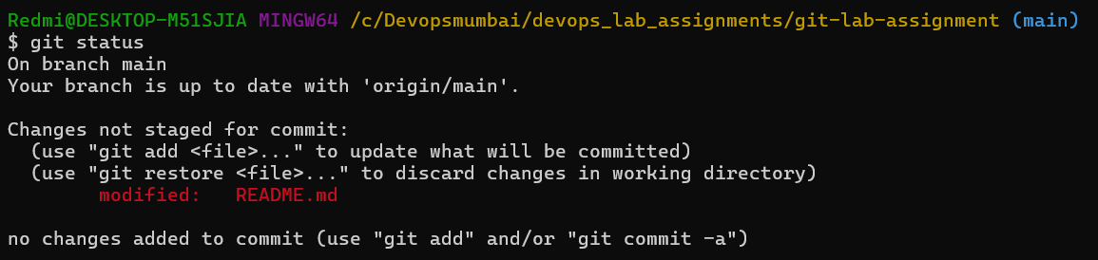

3. Try to run git pull and observe the error.  
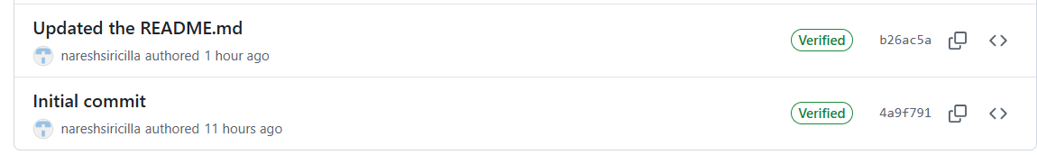  
  
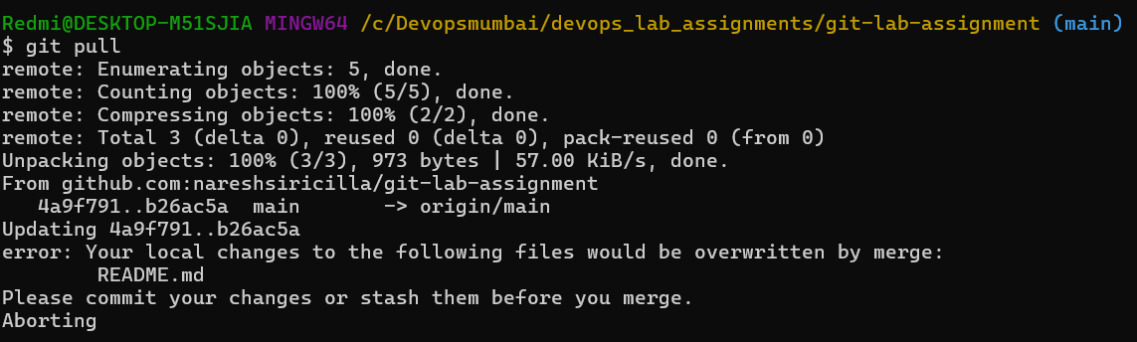

4. Use git stash to save your local changes.  


5. Run git pull again to fetch the teammate’s changes.  
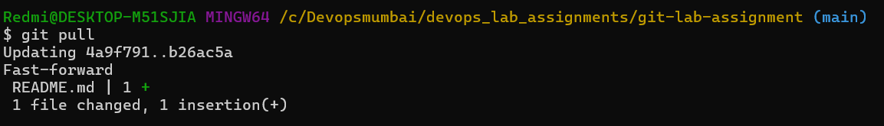

6. Apply your stashed changes and resolve any conflicts.  
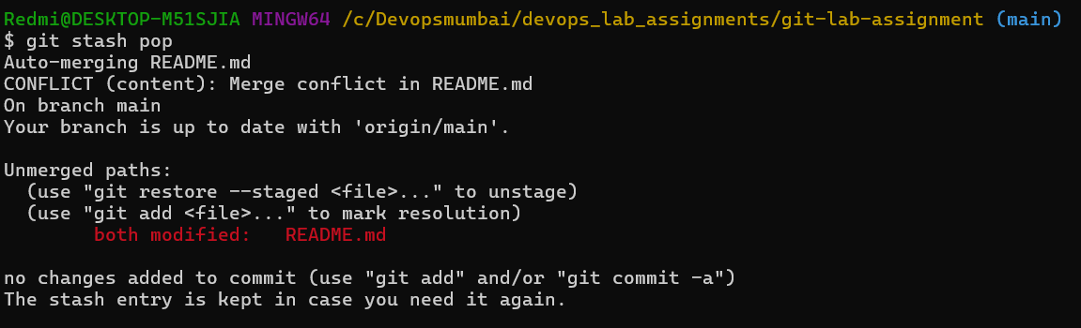

7. Commit and push the final version.  
